**Assignment -3**

Digital Marketing

|  |  |
| --- | --- |
| Student Name | GAYATHRI P |
| Student Register Number | 953720104013 |
| College Name | AAA College of Engineering and Technology |
| Naan Mudhalvan ID | 03E2753381821818C42440FC42DF97BF |

**QUESTION:**

**SOCIAL MEDIA ADVERTISEMENT POSTER USING CANVA:**

**Poster link:**

[**https://www.canva.com/design/DAFypCKSHkc/V1GP758yVa73yOaKJHSHMQ/edit?utm_content=DAFypCKSHkc&utm_campaign=designshare&utm_medium=link2&utm_source=sharebutton**](https://www.canva.com/design/DAFypCKSHkc/V1GP758yVa73yOaKJHSHMQ/edit?utm_content=DAFypCKSHkc&utm_campaign=designshare&utm_medium=link2&utm_source=sharebutton)

**Poster Title: Karuku Moruku Sweets**

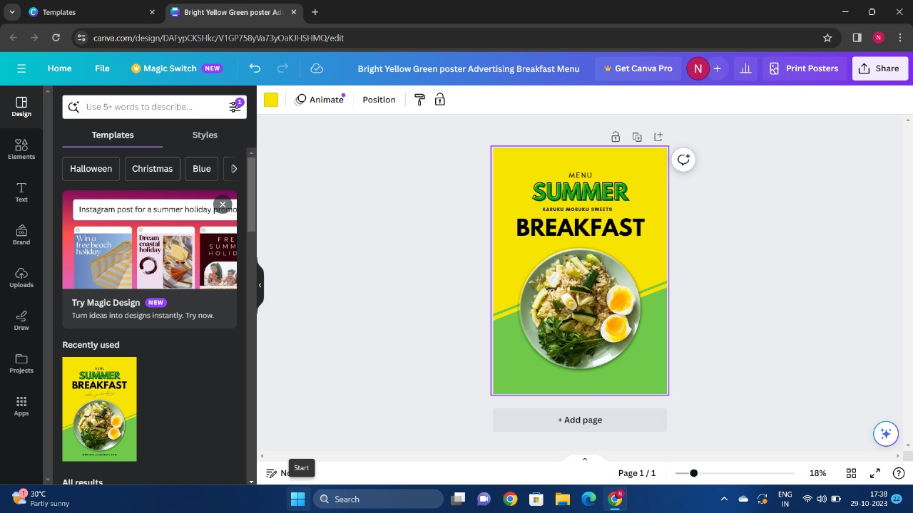

**Poster:**

